ASSIGNMENT-01
NAME :C Chahath Harshiya
EMAIL : chahathharshiya.c@gmail.com
TITLE :DATA ANALYTICS WITH TABLEAU
ROLL NO : 22AK1A0542
COLLEGE :AITS-TPT
“The following visualizations are created to clearly represent the data.”
- Stacked Bar Chart
- Donut Chart
- TreeMap Chart
- Bubble Chart
- Circle Chart
- Line Area Chart

1. STACKED BAR CHART
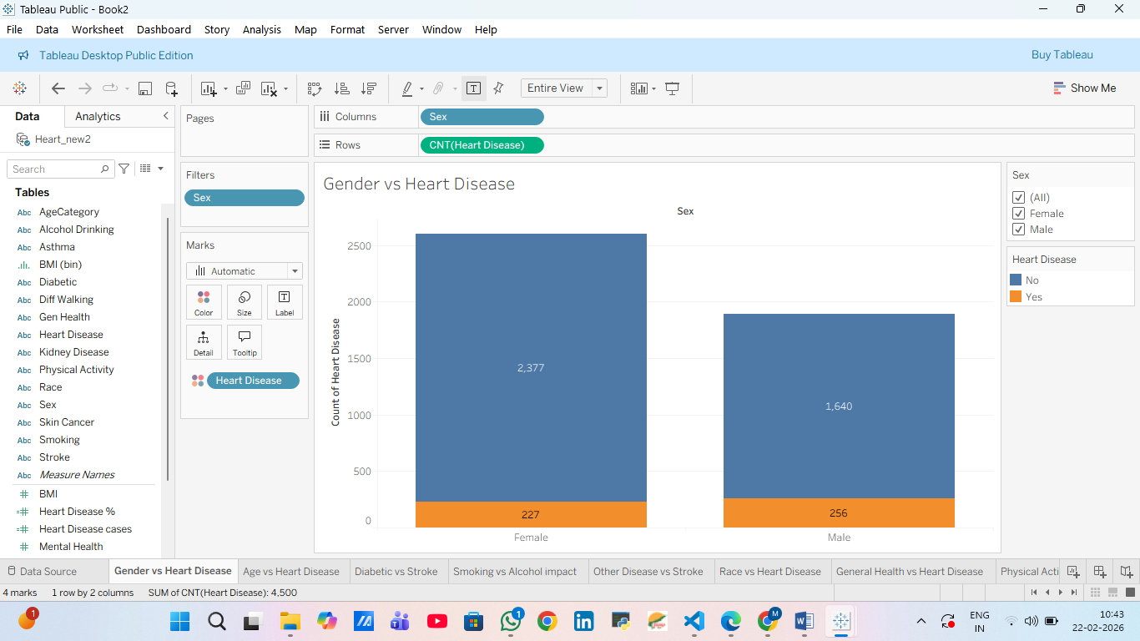

2.DONUT CHART
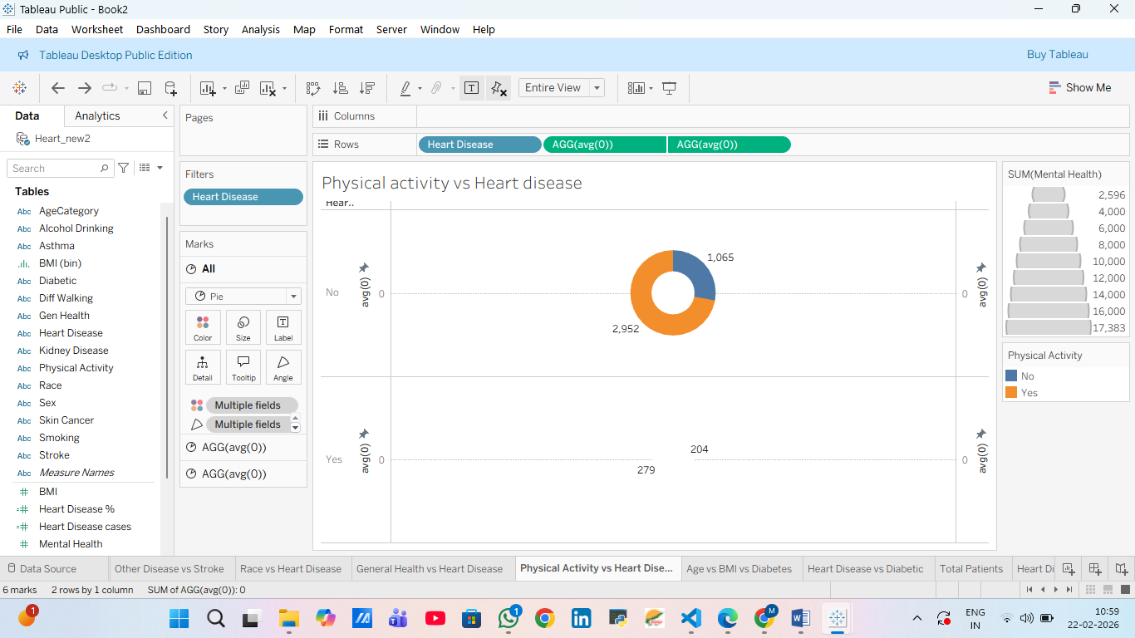

3.TREE MAP CHART
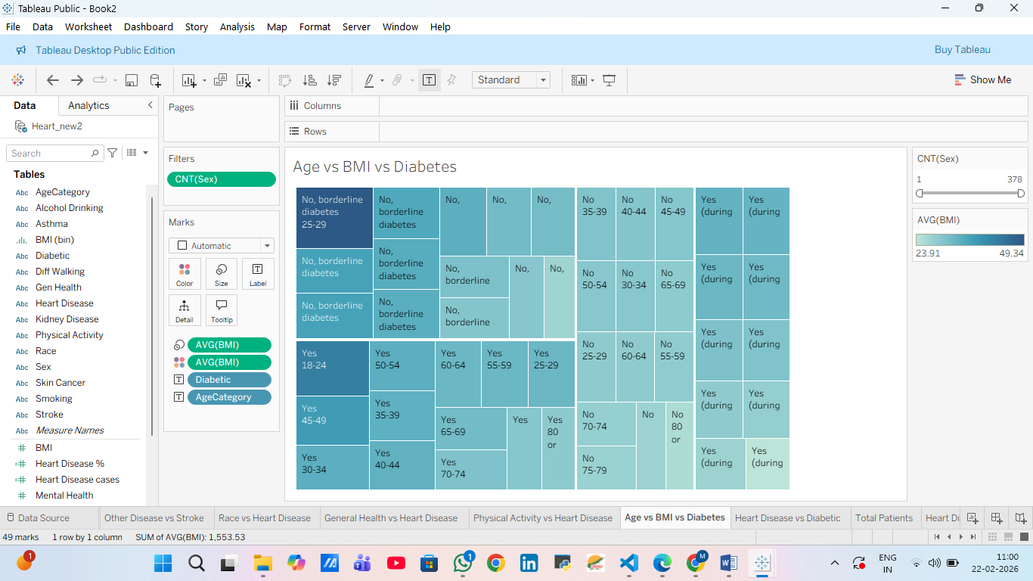
4.BUBBLE CHART
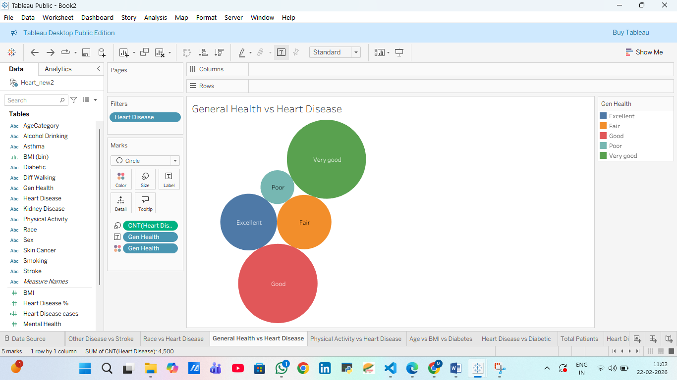

5.CIRCLE CHART
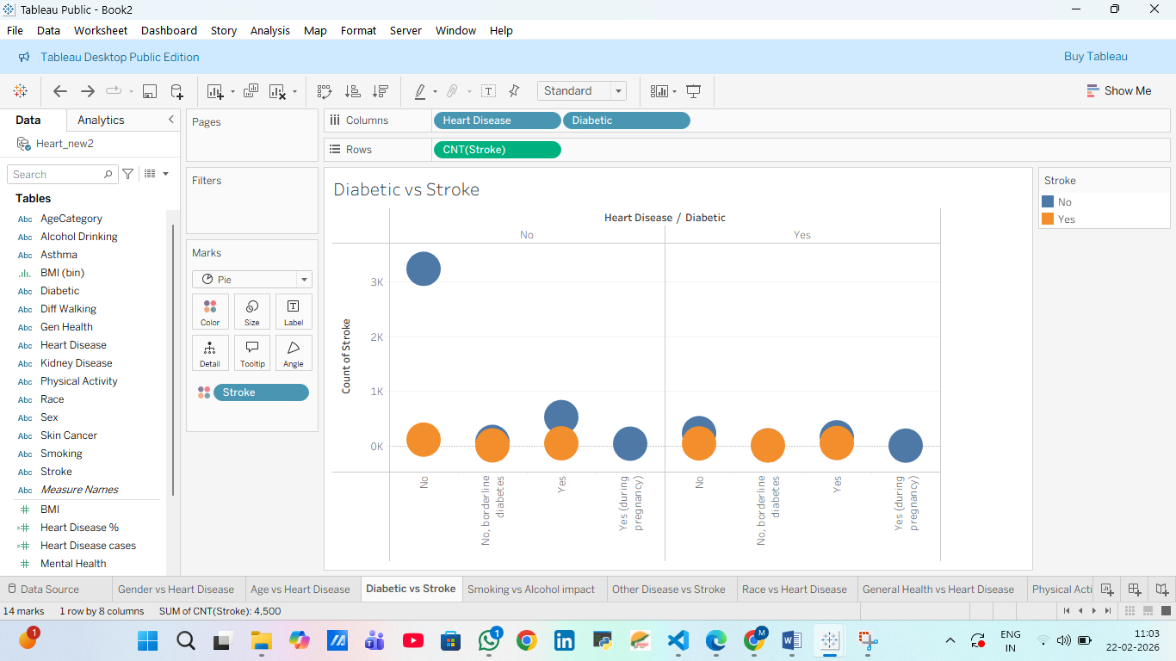
6.LINE AREA CHART
